ASSIGNMENT NO;01
QUESTION NO;01 (CODE)
#include<iostream>
using namespace std;

int main()
{
int x,y,m,b;

cout << "Enter the value of slope:\n";
cin>>m;
cout << "Enter the value of x-coordinate:\n";
cin>>x;
cout << "Enter the value of y-intercept:\n";
cin>>b;
y=m*x+b;
cout << "The value of y-coordinate is: y="<<y;
return 0;
}

QUESTION NO;01 (OUTPUT)
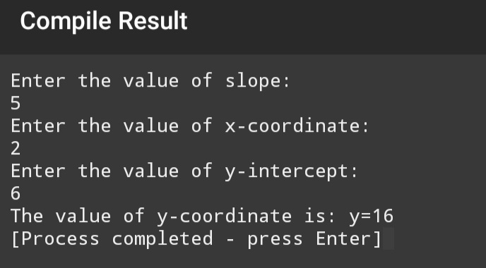
QUESTION NO;02 (CODE)
#include<iostream>
using namespace std;

int main()
{
float score_isl(0),score_prog(0),score_ict(0);
float score_phy(0),score_math(0),score_average;
cout << "Enter the score of islamiat:\n";
cin>>score_isl;
cout << "Enter the score of programming:\n";
cin>>score_prog;
cout << "Enter the score of ICT:\n";
cin>>score_ict;
cout << "Enter the score of physics:\n";
cin>>score_phy;
cout<< "Enter the score of math:\n";
cin>>score_math;
score_average=score_isl+score_prog+score_ict+score_phy,score_math/5;
cout << "The average score is: average_score="<<score_average;
return 0;

}

QUESTION NO;02 (OUTPUT)
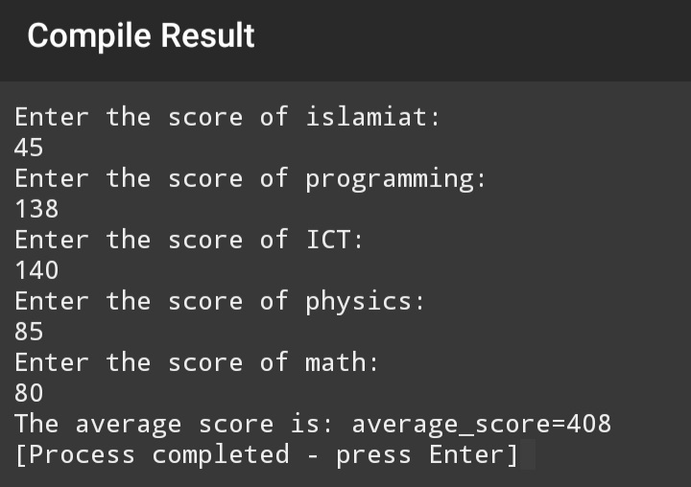
QUESTION NO;03 (CODE)
#include<iostream>
using namespace std;

int main()
{
float x,a,b;

cout << "which type of conversion do you want\n";
cout<<"1) PKR to £\n";
cout<<"2) £ to PKR\n";
cin>>x;
if(x==1){
cout<<"You have selected '1' Enter the amount:\n";
cin>>a;
cout<<"Converted amount is:"<<a/254<<" pound"<<endl;
}
else if(x==2){
cout<<"You have selected '2' Enter the amount:\n";
cin>>b;
cout<<"Converted amount is:"<<254*b<<" PKR"<<endl;
}
else {
cout<<"Invalid input!\n";

}
return 0;
}

QUESTION NO;03 (OUTPUT)
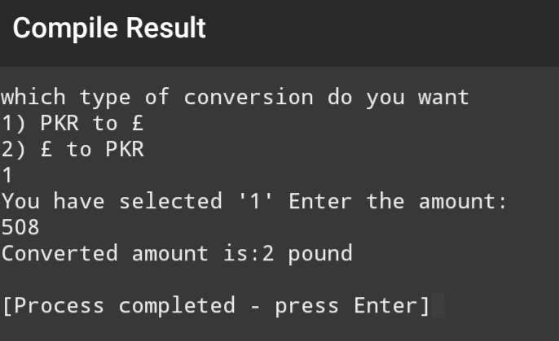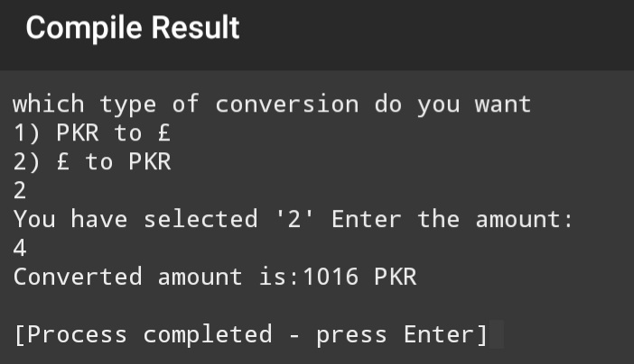
QUESTION NO;04 (CODE)
#include<iostream>
using namespace std;

int main()
{
int x,y,sum(0);

for(x=1; x<=10; x++){
cout <<"Enter the "<<x<<" number: ";
cin>>y;
sum=sum+x;
}
cout<<"sum="<<sum<<endl;
return 0;
}

QUESTION NO;04 (OUTPUT)
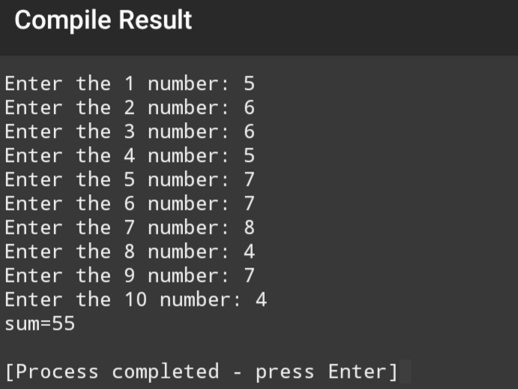
QUESTION NO;05 (CODE)
#include<iostream>
using namespace std;

int main()
{
int x,y,sum(0);
cout<<"Enter the number till which do you want to sum"<<endl;
cin>>y;
cout<<"(";
for(x=1; x<=y; x++){
if(x!=1)
{
cout<<"+";
}
cout<<x;
sum=sum+x;
}
cout<<")"<<endl;
cout<<"sum="<<sum<<endl;
return 0;
}

QUESTION NO;05 (OUTPUT)
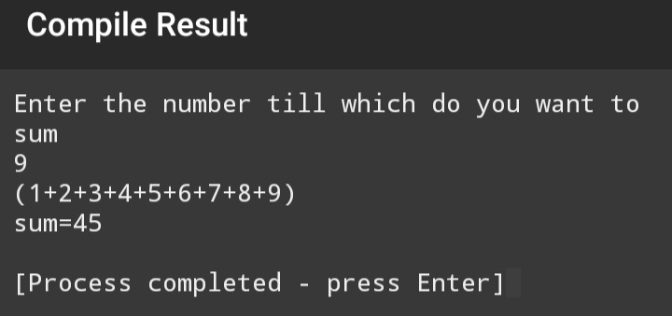
QUESTION NO;06 (CODE)
#include<iostream>
using namespace std;

int main()
{
int x,y,fac(1);
cout<<"Enter a positive integer number for which to show the factorial"<<endl;
cin>>y;
cout<<"Factorial("<<y<<")=";
for(x=1; x<=y; x++){
if(x!=1){
cout<<"*";
}
cout<<x;
fac=fac*x;
}
cout<<"="<<fac;

return 0;
}

QUESTION NO;06 (OUTPUT)
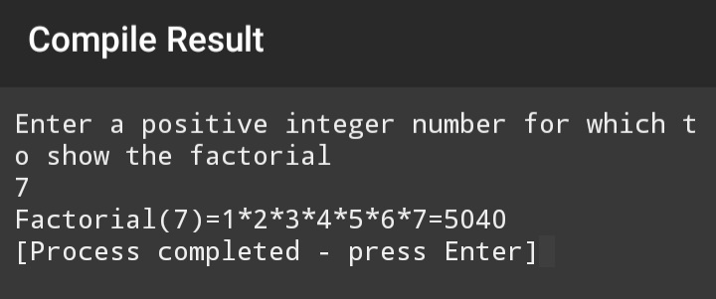
QUESTION NO;07 (CODE)
#include<iostream>
using namespace std;

int main()
{
int a,b,max(0),min(0);
cout<<"Enter six numbers:\n";

for(a=1; a<=6; a++){
cout << "Enter number "<<a<<"_:";
cin>>b;
if(a==1){
max=b;
min=b;
}

if(b>max){
max=b;
}

if(b<min){
min =b;
}
}

cout<<"Maximum="<<max<<endl;
cout<<"Minmum="<<min<<endl;

return 0;
}

QUESTION NO;07 (OUTPUT)
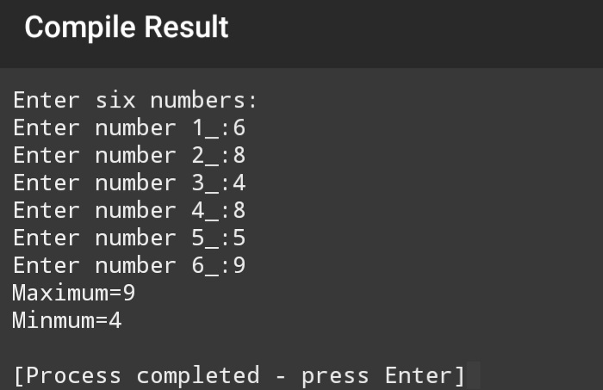
QUESTION NO;08 (CODE)
#include<iostream>
using namespace std;

int main()
{
int num1(0),num2(1),next_term;
cout<<num1<<", "<<num2;
for(int i=1; i<=18; i++){

next_term=num1+num2;
num1=num2;
num2=next_term;
cout<<", "<<next_term;
}
return 0;
}

QUESTION NO;08 (OUTPUT)
